**Role play: The multi-purpose dam (based on FOMI, similar case to GERD)**

The objective of this role play is to develop indicators that integrate the point of view of other sectors.

**Step-by-step guide**

**Step 1: Setting the scene**

Build 4 (large) working groups by sector (Water, Energy, Agriculture and Environment) and 1 group for the Office of the Presidency.

Task: Present the role-play and the case study. The main objective of the dam project must be clear.

Timeframe: 15 minutes

**Step 2: Group work**

Task: Each group writes the 2 main objectives of the project for their sector, with its respective indicators.

Timeframe: 30 minutes

**Step 3: Presenting indicators**

Task: Each group presents their indicators and collates them.

Timeframe: 15 minutes

**Step 4: Intersectoral discussion**

Task: Go to the next sector and negotiate/discuss your indicators.

Timeframe: 30 minutes

**Step 5: Representing interests**

Task: At the end of the rotation, the indicators are collated on 4 tables and presented/defended in plenary. Each group must defend its indicators of their sector for the implementation of the project.

Timeframe: 20 minutes

**Step 6: Final discussion**

Task: Plenary discussion to select indicators that are compatible with other sectors (The Office of the Presidency).

Timeframe: 10 minutes

**Expected result:**

Balanced indicators looking for methods to achieve a consensus as shared as possible, ideally with the tools presented during the antecedent sessions.

**The dam project**

Located in the Guinean highlands, the site for the Fomi dam on the Niandan river, 39 km from its confluence with the Niger river, was identified already in 1940, and a small dam was built. Between 1950 et 2013, several attempts were made to build a larger dam, and multiple financial, technical and environmental feasibility studies were carried out. The political priority given to the project under Guinean President Alpha Condé brought the topic to the centre of the national political agenda and therefore also to that of Mali and all other Basin countries, due to the magnitude of the project and the possible consequences downstream. Since 2014, and within the World Bank financed “Project for the development of Water Resources and Sustainable Ecosystem Management” the project had regained some of its momentum, notably with the call to re-evaluate the possible environmental and social impacts. The construction of the dam could then start relatively soon, depending on the availability of funding. The question remains: which project? With which objectives?

Map showing the Niger river basin (green), the river course and the strategical position of the Fomi dam at the basin’s head.

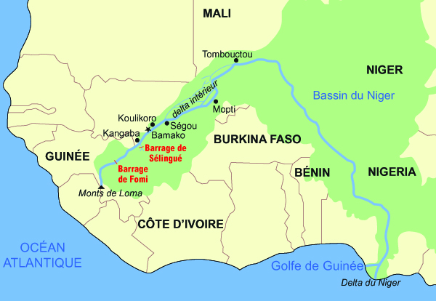

Figure 1: Map showing the Niger river basin (green), the river course and the strategical position of the Fomi dam at the basin’s head.

**A national project**

At the national level, one of the first interests of the Fomi dam project is to provide local households, markets and the mining industry with energy. It is then from the perspective of the great hydroelectric potential that the project was conceived in the first place. With an estimated cost of 250 million euro, the Fomi dam could have a power of about 100MW and provide 374 GWh, which represents around 3% of the total estimated national demand for 2030 (3).

The water reservoir could furthermore irrigate around 100 000 ha of agricultural land in Guinea, as well as provide fishing and fish-farming opportunities. The population to be displaced is estimated at over 45 000 people, and for this reason a new site seems to have gained preference among the project’s managers and contractors : 15 km upstream, the populations to be displaced would only amount to around 5 000.

The project’s possible impacts are not at all limited to the Guinean territory. The dam’s position, at the head of the third largest basin in Africa and the largest in West Africa, means that several aspects have to be considered, especially for countries downstream. On an economic and social level, changes in the river´s regime and discharge would demand that agricultural and economical activities adapt significantly. On an environmental level, certain ecosystems and humid zones would be affected, notably the Niger River Inner Delta, in Mali. On a political and regional integration level, the project raises questions vis-à-vis downstream countries, around, for example, who decides on water retention or release. In short, the typical questions of a large project of this kind in a transboundary context.

**A project of common interest for the region**

Within the framework of basin-scale planning performed under the coordination of the Niger River Basin Authority (NBA), the project for the Fomi dam has been identified by the nine member states, along with two other dam projects (the Taoussa dam in Mali and the Kandadji dam in Niger) for its potential to regulate the Niger’s discharge beyond its significant seasonal variations. In a region that has a rainy season typically concentrated in a period of only three months, the need to retain water to maximise its productivity and effectiveness both at the economic, social and environmental levels is significant.

Regulating the discharge of Niger’s main course would potentially allow to expand irrigation and agricultural production potential, thus improving security and independence of food production and provision in the region. The NBA’s Sustainable Development Action Plan estimates for example that the Fomi dam could provide for the development of improved irrigation as far as Niger (the country), where 10 000 ha of irrigated farmland could be developed. Discharge control throughout the year would also allow for improved navigation and regional commerce on the river to be further developed.

It is of course evident that the artificial control of the river´s natural regime would entail a change in the relation between the river and the ecosystems it sustains throughout its seasonal fluctuations. The impact would also reach all human activities depending directly on these ecosystem’s natural resources, for example fishing and rice farming, which depend on the seasonal flooding of certain areas of the basin. Furthermore, reorienting the dam’s main goal from hydropower to river discharge regulation would have a significant influence on financial calculations of the economic viability of the project.