Interactive session 5: Distribution of livelihood assets

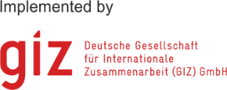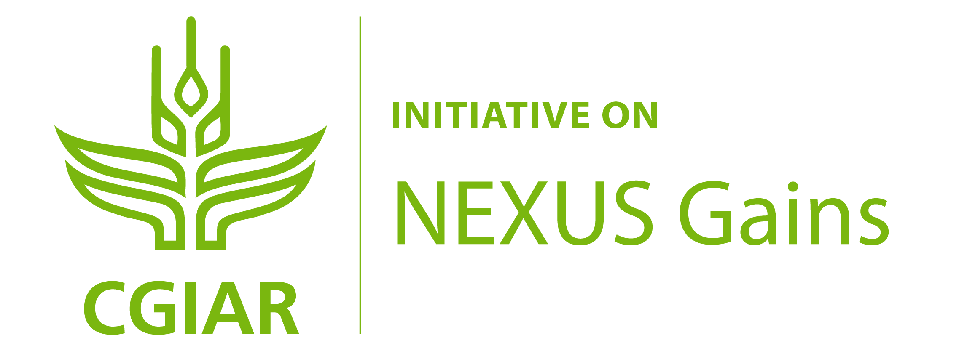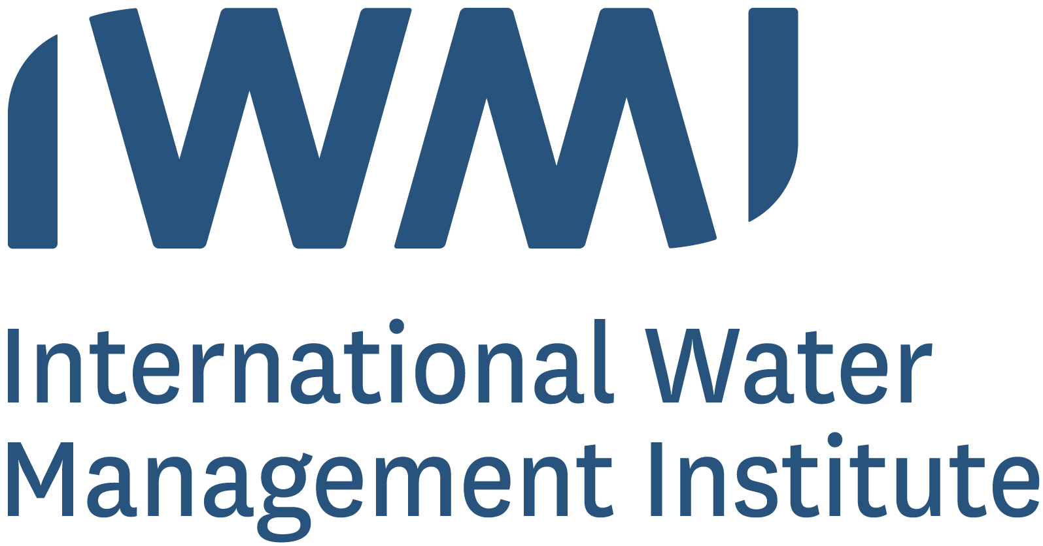

**Interactive session 2 : Distribution of livelihood assets**

## The objective of this exercise is to analyse how Water-Energy-Food-Ecosystems (WEFE) interventions may affect different stakeholders differently. We will use the Sustainable Livelihoods Framework to help break down the types of potential impacts on the distribution of natural, physical, financial, human, social and political capital (assets) among stakeholder groups.

Step 1: Group discussion on stakeholder identification

**Set up:**

* Build working groups consisting of 3-5 persons. If possible, each group should include people with different backgrounds, working in different sectors or at different levels from local to national or international.
* Use the same example of a water-energy-food-ecosystems management context and issues as in the Interactive session 1 on stakeholder identification in this module, as well as the stakeholder list you came up with. *If you skipped the session 1, add an extra 10-15 minutes discussion time to identify the management context and 2-3 groups of key stakeholders, including most marginalised and most powerful stakeholder groups.*

**Task:**

* Select one technology-oriented intervention that could be implemented to address the WEFE management issues. Commonly used technology interventions in the WEFE nexus space include:
  + Solar irrigation to increase agricultural production while reducing dependency on fossil fuels.
  + Treating wastewater and using it for irrigation to reduce pressure on water resources
  + Building or restoring natural water reservoirs that help maintain water supply for agriculture between seasons, reduce flood risks, and contribute to other ecosystem services
  + Land- and water-saving urban agriculture through vertical farming, rainwater harvesting and grey water recycling
* Discuss:
  + How can this technology intervention affect the distribution of different assets among the key stakeholder groups? Box 1 includes examples of the different types of assets to aid your discussion. Summarise your discussion in Table 1 on the next page.
  + Optional: Select 1 or 2 potential negative impacts on the assets of the marginalised stakeholders and identify solutions to mitigate these risks. Summarise your discussion in Table 2.

**Timeframe:** 25 minutes for the discussion and compiling the results in the table (+ 10-15 minutes if doing this as a standalone exercise without the preceding Interactive session 1)

**Please see the following pages for the tables that you can use to collect your answers.**

## Step 2: Presentation of group work results

**Objective:** Discuss results in plenary.

**Task:** Each group should appoint one member who presents your group work in the plenary. Focus on the impacts that may be unintended and unexpected, including any negative impacts on the assets of some stakeholder groups. You can also mention possible questions that remained open in your group discussion.

**Timeframe:** 3 minutes for each group presentation.

## Step 3: Plenary discussion

**Objective:** Comparison of the group results and further discussion in the plenum.

**Task:** Compare your results with the other groups in a plenary discussion. Where could you observe similarities or differences? What did surprise you?

**Timeframe:** 15 minutes for the plenary discussion.

|  |
| --- |
| Box 1. Examples of different types of assets:   * Natural capital such as land, water, fuelwood, wild food sources, or genetic resources * Physical capital such as irrigation and road infrastructure, transport, electricity, tools and machinery, storage, or production inputs like seed, fertilisers, and pesticides. * Financial capital such as regular income, savings, liquid assets, or formal and informal credit facilities. * Human capital such as knowledge and skills, education and training, health, nutrition, or capacity to work. * Social capital such as membership in formal and informal groups like Water User Associations and producer groups, collaboration, or access to opportunities through social networks. * Political capital such as citizenship, enfranchisement, or effective participation in governance. |

### Template for collecting results

Table 1: Potential effects of a WEFE nexus intervention on different types of assets

|  |  |  |  |  |  |
| --- | --- | --- | --- | --- | --- |
| Intervention: |  | | | | |
| Stakeholder group 1: | | | | | |
| **Natural capital**  Hill scene with solid fill | **Physical capital**Tractor with solid fill | **Financial capital**Coins with solid fill | **Human capital**  Group with solid fill | **Social capital**  Cycle with people with solid fill | **Political capital**  Bank with solid fill |
|  |  |  |  |  |  |
| Stakeholder group 2: | | | | | |
| **Natural capital**  Hill scene with solid fill | **Physical capital**Tractor with solid fill | **Financial capital**Coins with solid fill | **Human capital**  Group with solid fill | **Social capital**  Cycle with people with solid fill | **Political capital**  Bank with solid fill |
|  |  |  |  |  |  |

|  |  |  |  |  |  |
| --- | --- | --- | --- | --- | --- |
| Stakeholder group 3: | | | | | |
| **Natural capital**  Hill scene with solid fill | **Physical capital**Tractor with solid fill | **Financial capital**Coins with solid fill | **Human capital**  Group with solid fill | **Social capital**  Cycle with people with solid fill | **Political capital**  Bank with solid fill |
|  |  |  |  |  |  |

Table 2: Optional: Solutions to increase potential positive impacts or reduce risks of negative impacts on marginalised stakeholders

|  |  |
| --- | --- |
| Potential impact | Solutions |
|  |  |
|  |  |

This exercise is part of a Water-Energy-Food (WEF) Nexus training material on gender equity and social inclusion, developed by the Alliance of Bioversity International and CIAT in collaboration with the GIZ Nexus Regional Dialogues Programme. Recommended citation:

Jalonen, R., Elias, M., Zaremba, H., Petesch, P., Estrada-Carmona, N., Tsvuura, S., Koirala, S. 2023. Gender equity and social inclusion in the water-energy-food-ecosystems (WEFE) nexus: Frameworks and tools for moving from resource-centric to people-centric WEFE nexus approaches. *Online learning module*. Alliance of Bioversity International and International Center for Tropical Agriculture (CIAT), Rome, Italy.