Interactive session 4: Stakeholder analysis

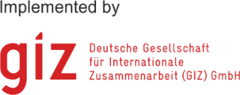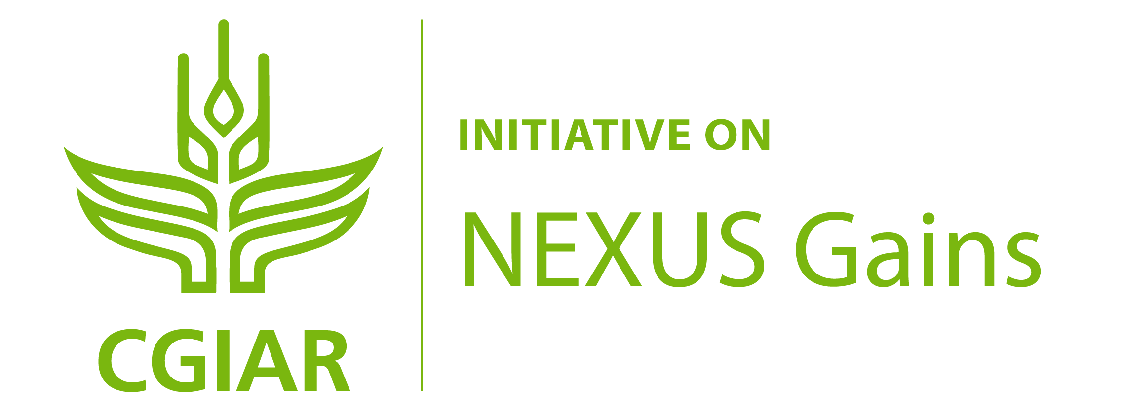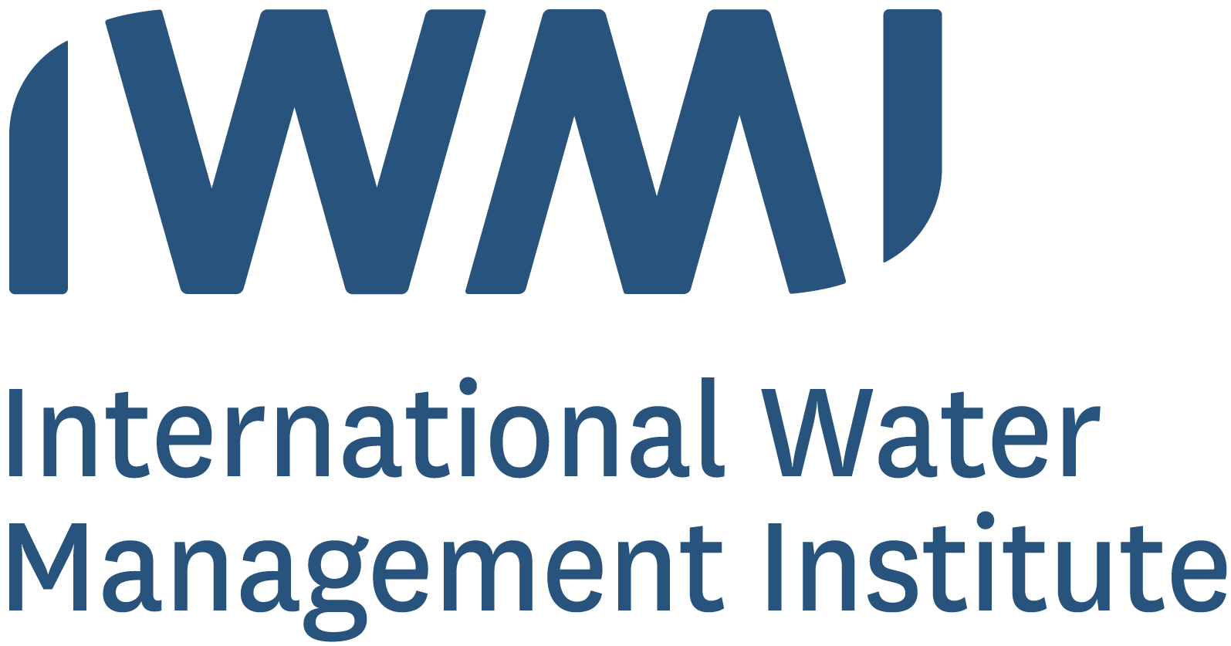

# Interactive session 1: Stakeholder analysis

Contents [option 2 continued]

Heading 1 Error! Bookmark not defined.

Heading 2 **Error! Bookmark not defined.**

Heading 3 **Error! Bookmark not defined.**

Heading 2 **Error! Bookmark not defined.**

Heading 3 **Error! Bookmark not defined.**

Figures and charts Error! Bookmark not defined.

Tables Error! Bookmark not defined.

Shapes and boxes Error! Bookmark not defined.

[Key messages Error! Bookmark not defined.](https://scriptoria.sharepoint.com/Home/pnc/GIZ/Nexus%20Regional%20Dialogues/Implementation/05_WS3/Templates/03_Template_development/Word/OLD/GIZ_Nexus_Word_Template_v1.2_KN.docx#_Toc75269046)

References Error! Bookmark not defined.

The objective of this exercise is to identify different types of stakeholders who are affecting and affected by the interlinked water, energy, food and ecosystem (WEFE) management decisions.

## Step 1: Group discussion on stakeholder identification

Build working groups consisting of 3-5 persons. If possible, each group should include people with different backgrounds, working in different sectors or at different levels from local to national or international.

**Task:** Discuss the following points in your group and summarise your findings in the tables on the next page:

* Select a case where there are interlinked water, energy, food and ecosystem (WEFE) management issues. You can either discuss the training module case study of impacts of drought on water management, agriculture, and energy supply in the city of Mostanova and its surroundings or think of a situation from your own country or context which you are familiar with.
* Discuss: Who are the different types of stakeholders of WEFE management decisions in this context?
* Try to think of stakeholders across different levels, and different social groups, e.g., based on gender, ethnicity, occupation, urban/rural residence, etc.
* After the stakeholders have been identified:
  + Which stakeholders would be the most affected by changes in the availability of and access to water, energy, food and ecosystem services in that context and why?
  + Which stakeholders have the most power to influence management decisions about these resources and why?

**Timeframe:** 25 minutes for the discussion and compiling the results in the table.

**Please see the next page for the table that you can use to collect your answers.**

## Step 2: Presentation of group work results

**Objective:** Discuss results in plenary.

**Task:** Each group should appoint one member who presents your group work in the plenary. You can also mention possible questions that remained open in your group discussion.

**Timeframe:** 3 minutes for each group presentation.

## Step 3: Plenary discussion

**Objective:** Comparison of the group results and further discussion in the plenum.

**Task:** Compare your results with the other groups in a plenary discussion. Where could you observe similarities or differences? What did surprise you?

**Timeframe:** 15 minutes for the plenary discussion.

### Template for collecting results

Table 1: Stakeholders affected by WEFE management decisions

|  |  |
| --- | --- |
| Local rights-holders*  Marker with solid fill | Other local stakeholders  Map with pin with solid fill |
|  |  |
| National  Stakeholders  Flag with solid fill | International stakeholders  Earth globe: Americas with solid fill |
|  |  |

*\*Local rights-holders have customary and historical rights to determine how natural resources are used and by whom, in ways that are fundamental to their human rights. This can include indigenous peoples and marginalised groups in local communities.*

Table 2: Most affected and most powerful stakeholders

|  |  |
| --- | --- |
| Most affected stakeholders | Reasons |
|  |  |
| **Stakeholders with most  decision-making power** | **Reasons** |
|  |  |

This exercise is part of a Water-Energy-Food (WEF) Nexus training material on gender equity and social inclusion, developed by the Alliance of Bioversity International and CIAT in collaboration with the GIZ Nexus Regional Dialogues Programme. Recommended citation:

Jalonen, R., Elias, M., Zaremba, H., Petesch, P., Estrada-Carmona, N., Tsvuura, S., Koirala, S. 2023. Gender equity and social inclusion in the water-energy-food-ecosystems (WEFE) nexus: Frameworks and tools for moving from resource-centric to people-centric WEFE nexus approaches. *Online learning module*. Alliance of Bioversity International and International Center for Tropical Agriculture (CIAT), Rome, Italy.